Experiment:17 Date:15/08/2026

To Implement Feed Forward Neural Network

Aim:
To implement a simple Feed Forward Neural Network (FFNN) using Python.
Algorithm(Feed Forward Neural Network):
- Start
- Initialize the input values X1 and X2.
- Initialize the weights W1, W2 and bias B.
- Calculate the weighted sum of the input layer:
Z = (X1 × W1) + (X2 × W2) + B
- Apply the Sigmoid activation function:
H = 1 / (1 + e⁻ᶻ)
- Use the hidden-layer output H as input to the output layer.
- Multiply the hidden-layer output by the output weight W3.
- Calculate the output:
Y = H × W3
- Apply the Sigmoid activation function to obtain the final output.
- Display the hidden-layer output and final neural-network output.
- Stop

PROGRAM:

import math
def sigmoid(x):
return 1 / (1 + math.exp(-x))
print("FEED FORWARD NEURAL NETWORK")
x1 = float(input("Enter input 1: "))
x2 = float(input("Enter input 2: "))
w1 = float(input("Enter weight 1: "))
w2 = float(input("Enter weight 2: "))
bias = float(input("Enter bias: "))
hidden = sigmoid((x1 * w1) + (x2 * w2) + bias)
w3 = float(input("Enter output weight: "))
output = sigmoid(hidden * w3)
print("\nHidden Layer Output =", round(hidden, 4))
print("Final Network Output =", round(output, 4))

OUTPUT:

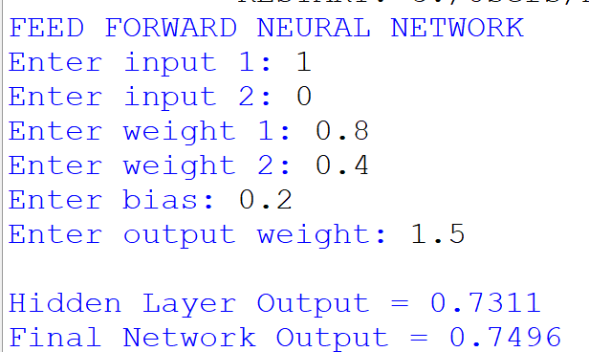

Result:
Thus, the Feed Forward Neural Network was successfully implemented and the output was calculated using forward propagation.

